INNOLOFT VENTURES | InnoTrack Daily Report | 20-Day Internship Program

DAILY INTERNSHIP REPORT
Submit this report on InnoTrack by 5:00 PM every day
SECTION 1 — STUDENT INFORMATION

Student Name | R TARUN | VTU ID | 28753
Branch / Dept. | B.Tech CSE | Internship Day No. | 09
Date | 09/06/2026 | Track (1 / 2 / 3 / 4) | 2
Project Title | Smart Crop Recommendation Engine - Agriculture | Mentor Name | Akhil

SECTION 2 — WHAT DID YOU LEARN TODAY?

Topic / Concept Learned (e.g. Random Forest, Flask routing, model saving...)
📦 DELIVERABLE — Colab notebook: CNN on MNIST achieving ≥95% test accuracy

SECTION 3 — WHAT DID YOU BUILD TODAY?

Code / Output / Feature Built (e.g. Built EDA section, trained model, created Flask form...)
Today, we enhanced the Crop Recommendation System by analyzing feature importance, checking class distribution, improving model explainability, generating user-friendly crop recommendations with confidence scores, and performing end-to-end testing using real-world sample inputs. We also created visual PNG reports to better understand and present the model's performance and predictions.
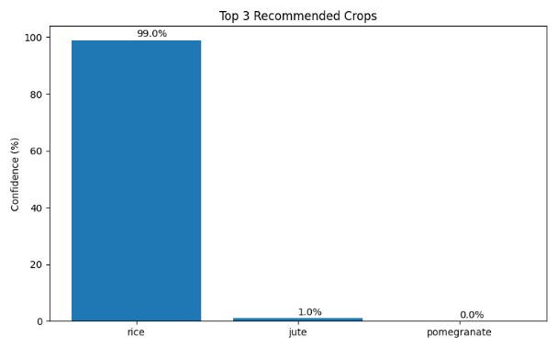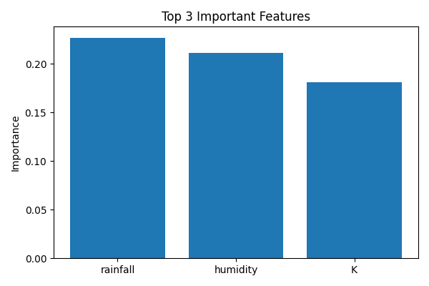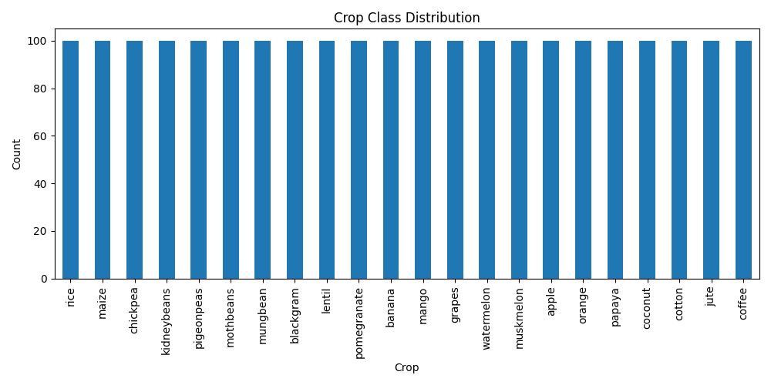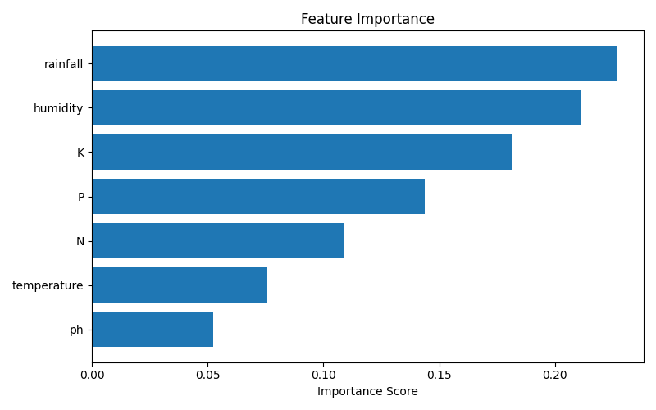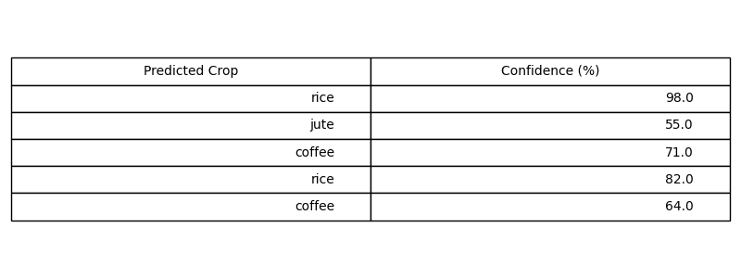

SECTION 4 — PROBLEMS FACED & HOW YOU SOLVED THEM

Error / Problem (e.g. ValueError when scaling — solved by dropping nulls first)
Model training was slow on large data

Missing values were present in the dataset

How I Fixed I (Describe your solution or what help you took)

Reduced parameter combinations and optimized training settings.

Removed null values using data cleaning techniques.

SECTION 5 — PLAN FOR TOMORROW

What will you do tomorrow? (e.g. Train Random Forest, compare with Logistic Regression, start Flask app)

SECTION 6 — LINKS & ATTACHMENTS

GitHub Repo / Commit Link | https://github.com/rtarun7879-byte/Veltech-Summer-Internship.git
Model Result / Colab Link
Deployed App Link (if any)
Additional Notes

SECTION 7 — SELF RATING FOR TODAY

Area | 1 | 2 | 3 | 4 | 5
Understanding of today's concept | ☐ 1 | ☐ 2 | ☐ 3 | ☐ 4 | ☐ 5
Hands-on coding confidence | ☐ 1 | ☐ 2 | ☐ 3 | ☐ 4 | ☐ 5
Progress on my project | ☐ 1 | ☐ 2 | ☐ 3 | ☐ 4 | ☐ 5
Overall satisfaction with today | ☐ 1 | ☐ 2 | ☐ 3 | ☐ 4 | ☐ 5

